Please read the following room information and complete the application form. Email completed forms to info@cwrc.org.uk.
Our centres are located in Cambridge and Peterborough city centres. We are not able to offer evening or weekend use currently. Please note that we are women-only centres.
CAMBRIDGE CENTRE INFORMATION:
Kahlo Room
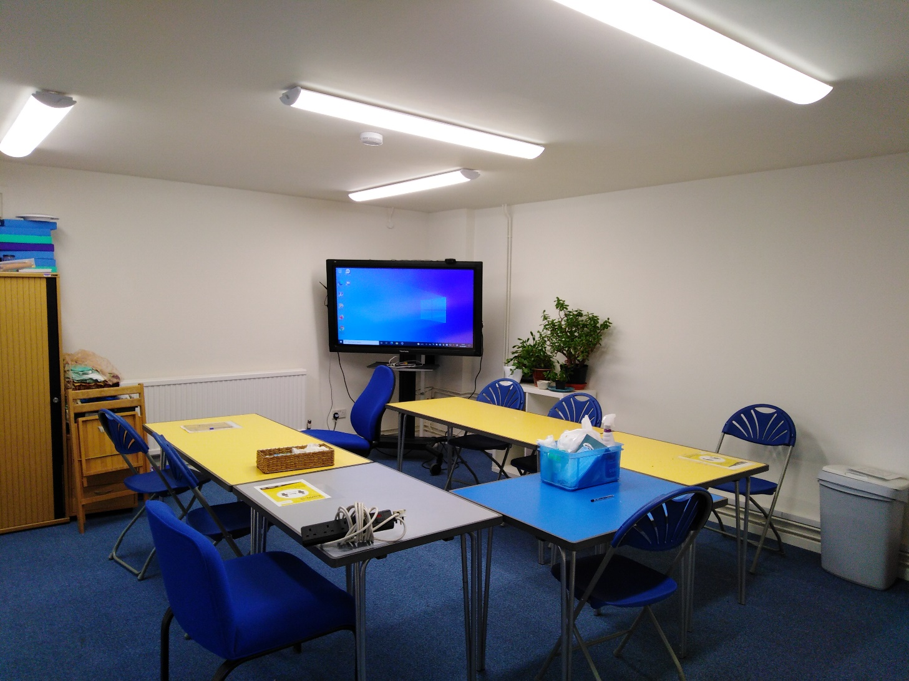
Downstairs group room with kitchen facilities (kettle, fridge, microwave, toaster, and sink) which is about 25.4 square meters (5.4 x 4.7). It also has a large touch screen that computers can plug into.

Atwood Room
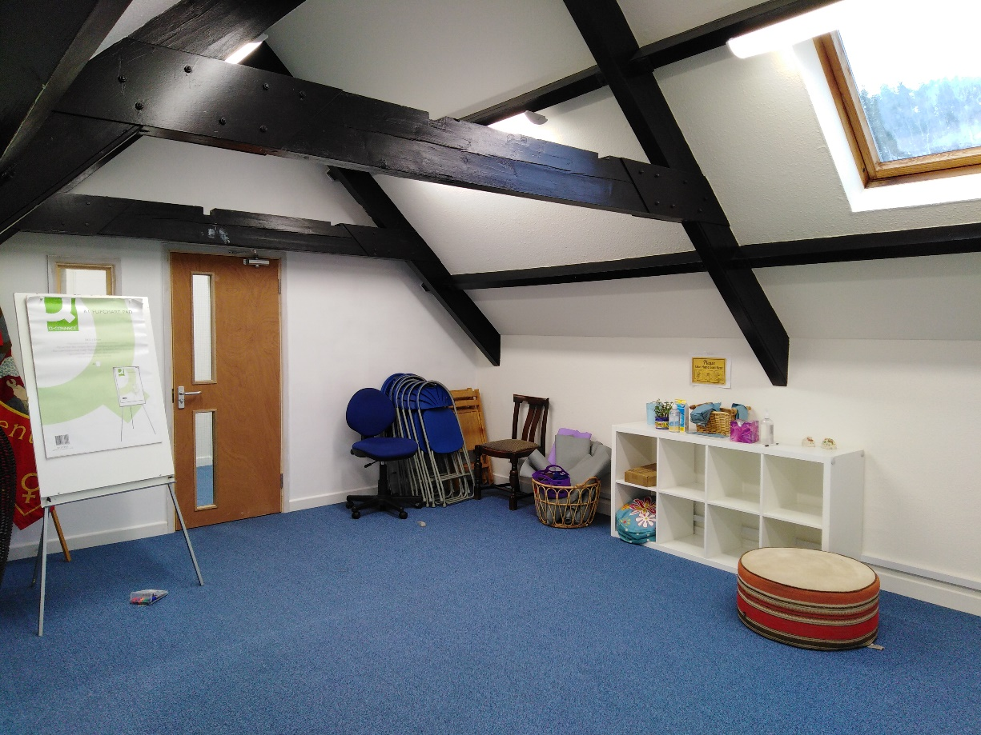
Large upstairs room which is also about 25.4 square meters (5.4 x 4.7).
Johnson Room – 1:1 room
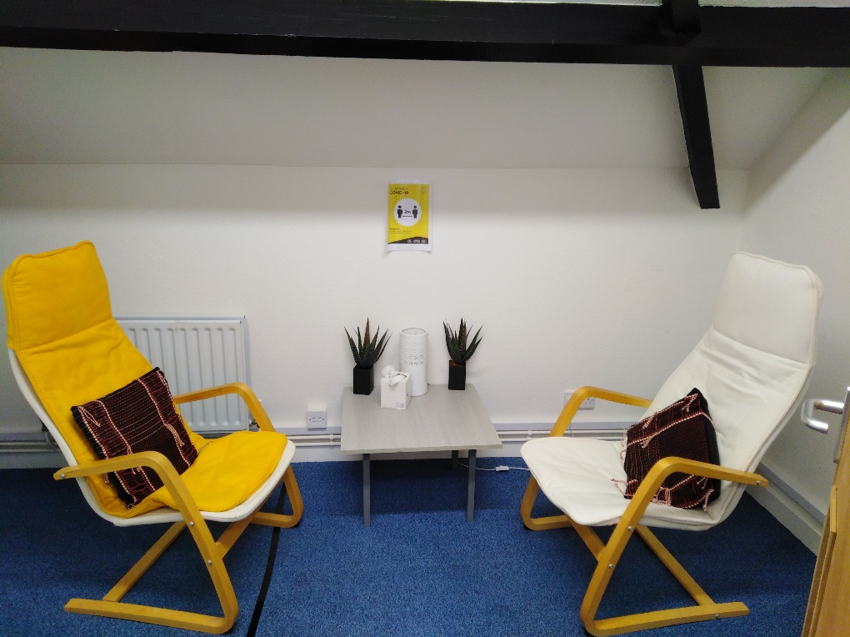
Small one to one room that is about 6.8 meters squared (3.1 x 2.3). This room could safely accommodate two people as we use it as a counselling room.
The larger rooms could probably fit between six and ten people socially distanced.
Cambridge prices
(Cambridge has the addition of hybrid delivery in the downstairs training room - £15 for use of computer)
Partnership rate for 1:1 room is £5 per hour for sessions/ half day rate £10 full day is £15
Outside org rate for 1:1 room is £10 per hour for sessions/half day rate £15/ full day is £30
For block bookings we can reduce the price: minimum block booking would be 3 months – maximum would be 1 year.
Additional services: Photo copying in Black and white (per A4 sheet) £00.10 Colour (per A4 sheet) £00.25, Flipchart easel, pen and pen kit (per meeting) £10.00

PETERBOROUGH CENTRE INFORMATION:
Joan of Arc Room
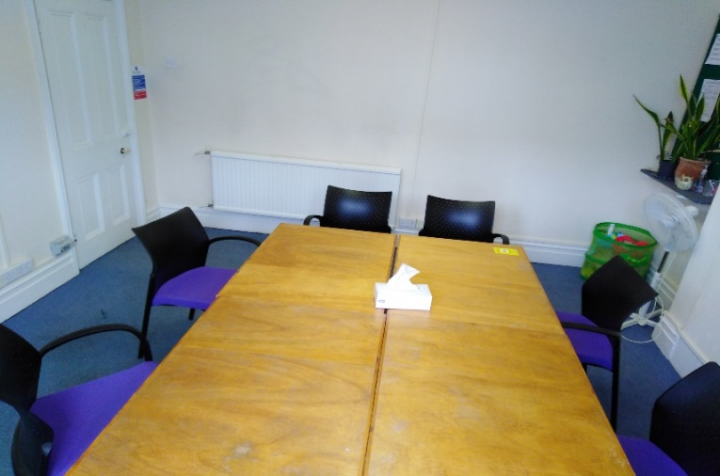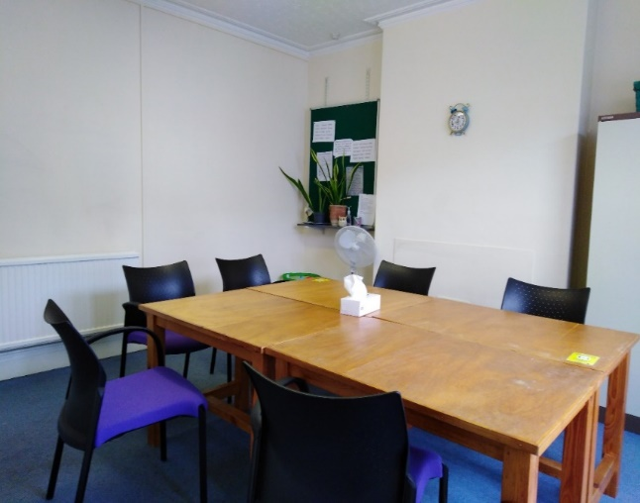
Joan of Arc is located on the ground floor. Easy access for people with disabilities. Light and spacious, facilities for tea and coffee. Free Wi-Fi. Maximum 6/8 people 16FT X 14FT

Oprah Winfrey Room
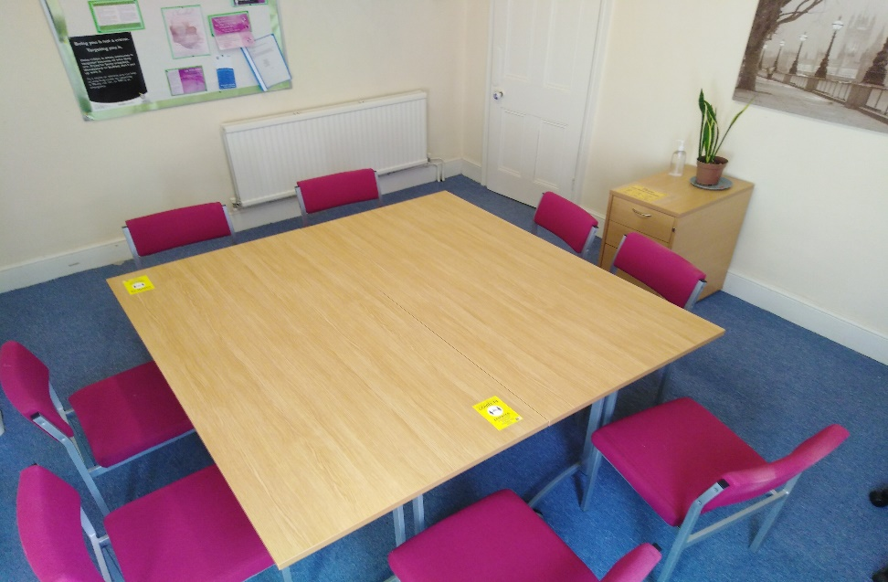
Oprah Winfrey room is located on first floor. Facilities for tea and coffee. Free Wi-Fi. Maximum 8/10 people, 16FT X 13FT
Hot desk
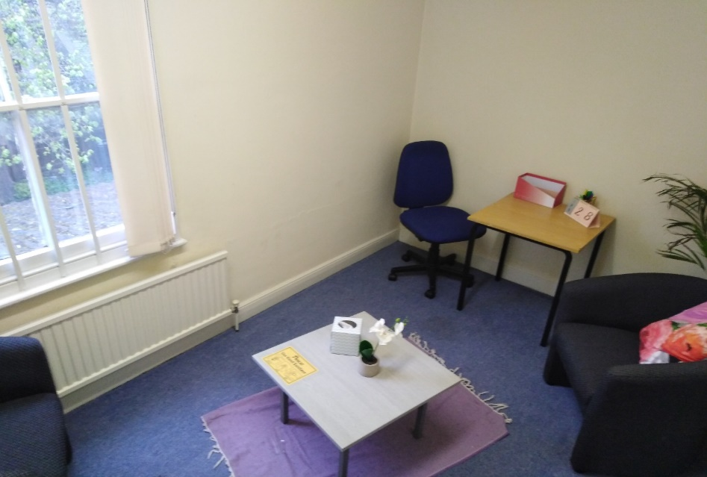
Hot desk is located on the first floor back of the building. Quiet relaxing area for 1:1 room, facilities for tea and coffee. Free Wi-Fi. Maximum 2 people, 12FT X 7FT.

Peterborough Prices
Partnership rate for 1:1 room is £5 per hour for sessions/ half day rate £10 full day is £15
Outside org rate for 1:1 room is £10 per hour for sessions/half day rate £15/ full day is £30
For block bookings we can reduce the price: minimum block booking would be 3 months – maximum would be 1 year.
Additional services: Photo copying in Black and white (per A4 sheet) £00.10 Colour (per A4 sheet) £00.25, Flipchart easel, pen and pen kit (per meeting) £10.00

ROOM BOOKING FORM
Applicant information:
Name
Company/Organisation
Address
Postcode
Phone
Email

Please indicate which room you would like to book:

Cambridge:
☐ Johnson Room - 1:1 Counselling
☐ Kahlo Room – Downstairs Group Room
☐ Atwood Room – Upstairs Group Room

Peterborough:
☐ Hot desk - 1:1 Counselling Room
☐ Oprah Winfrey Room – Larger Group Room
☐ Joan of Arc Room – Small Group Room

Please indicate any additional services you require:

☐ Photo copying in Black and white (per A4 sheet) £00.10
☐ Colour (per A4 sheet) £00.25
☐ Flipchart easel, pen and pen kit (per meeting) £10.00
Please indicate the date(s) you would like to book the room for:

Is this a recurring booking?

☐ Monthly
☐ Weekly
☐ Other (please state below)

Please indicate your payment rate:

☐ Partnership rate
☐ Outside organisation rate

If paying partnership rates, please state which partnership the discount is relevant to:

_______________________________________________________________

Any other details:

GDPR

Signed:

Date:

